Summer Car Wash Information

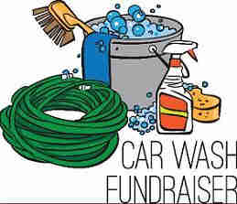
Our summer car washes are a great way for Express Members to get a jump start on fundraising for the year and it gives the group a chance to work together and have some fun. Stay tuned for more updates.

