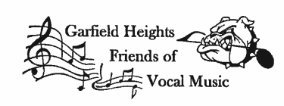
2021 - 2022 Annual Patron Drive
Each year Friends of Vocal Music asks for contributions for the Vocal Music Programs at the Garfield Heights Middle and High School. Your contributions go to directly support our students in Middle and High School, Center Stage Middle School Show Choir and the award-winning High School Show Choir, Music Express.
Thank you for supporting vocal music in Garfield Heights with your contribution of $_________.
Your name will appear in all our concert programs for this school year.
We appreciate your donation and invite you to attend the concerts

Friend $5.00 - $10.00 Super Patron +$50.00 - $100.00
Blue Patron +$10.00 - $25.00 Platinum Patron +$100.00 - $200.00
Gold Patron +$25.00 - $50.00 Director’s Club +$200.00

Name of business: _________________________________________________________________
(As you would like it to appear in the concert program)
Address: _________________________________________________________________________
_________________________________________________________________________
Phone: _________________________________ E-Mail: __________________________________
Student’s Name: ___________________________________________________________________
Group (circle one): Choir Center Stage Music Express
You can now donate directly using CashApp @ $FOVMExpress. If you’re donating to a specific student, be sure to put their name in the memo of your payment. Donations that do not have a student name will go to FOVM General Fund.